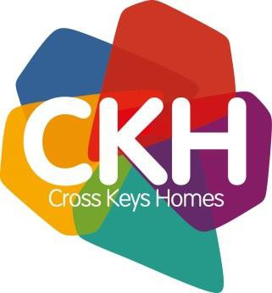
Volunteer role description
Volunteer role – Community Driver.

Reports to: | Chris Nice- Café Manager
Department/section: | Communities
Commitment level: | Flexible - Including Weekday Evenings. 7:30pm(get the call) – Pick up 8:30pm. Short notice. It depends on your availability and what food needs collecting from the supermarket. The aim is to have a pool of volunteer drivers available – coordinated by a WhatsApp Group.
Location: | Covering Supermarkets & Foodbanks in Peterborough e.g Tesco Werrington & Tesco Hampton.
Purpose of the voluntary role:
The WestRaven Community Café receives donations of food from local supermarkets at short notice. Usually in the evenings 7:30pm – 8:30pm. The Community Driver would collect the food and deliver it to the community café – so it can be used for the Community fridge.
Key responsibilities:
Collecting food donations from local supermarkets.
Delivering food to the Community café.
Completing expenses claim.
Reliability is essential as this is a vital service for our Community Café.
All journeys are planned and agreed in advance and you should only take on the number and length of journeys that you feel happy with.
As a volunteer Community Driver you must adhere to CKH Volunteer Safeguarding and Health & Safety best practice.
Volunteers must have their own mobile phone and be willing to join the WhatsApp Group that is established solely for the purpose of coordinating deliveries.

Key relationships:
Café Manager. Other Café staff and Volunteers. CKH staff. Supermarket staff

Skills, qualifications and experience required:
A full UK driving licence
Your own vehicle which is insured and taxed
Able to load / unload shopping to and from car
Training and support provided:
Mandatory volunteer training
Manual handling
Opportunity to attend any in house training that is relevant to your role.
Availability of parking at work location:
There is free parking at the WestRaven Café and at the supermarkets
Equipment:
A volunteer needs to provide a car. Official lanyard / name badge.
Expenses:
Mileage is paid at £0.45 pence per mile.
Is this role is eligible for a Disclosure and Barring Service (DBS) check, which is renewable every three years?
Yes
If yes, what level of DBS check which is required for this role?
Enhanced
No role description can cover every issue which may arise, and as a volunteer post-holder you may be expected to carry out other duties as required from time to time.

